Mosaic Maze: Post First Rehearsal Corrections:

Specific Mistakes in Perc 1 part:

- m. 4 - incorrect notes in the lower staff: Should be top G and C (if it was treble clef), as bar 1 beats 3 and 4

- m. 7 - incorrect notes in the upper staff: Should be D (not B)

- m. 29 – incorrect notes in the upper staff: Should be B (not D)

- m 82 - Incorrect notes in both hands: Should be low G on upper staff and low F in lower

- m. 84 - incorrect notes in both hands: Second note should be B on upper staff and A on lower

- m. 91 - missing mf dynamic in RH, second note

IMPORTANT CHANGES TO PERCUSSION NOTATION:

I made some changes to Percussion Notation, Please adjust carefully!
The changes are:

Perc 1: they asked me to make the same note heads for both Wood Plank and Wood blocks, because they are always coupled and not independent. Also I added 2 new toms, now totaling 5 toms. Also, please change instrument name from “Wood Plancks” to “Low Wood Planks”

Perc2: I added 3 bongos and 2 congas to the skin instruments.

Please use the following diagram

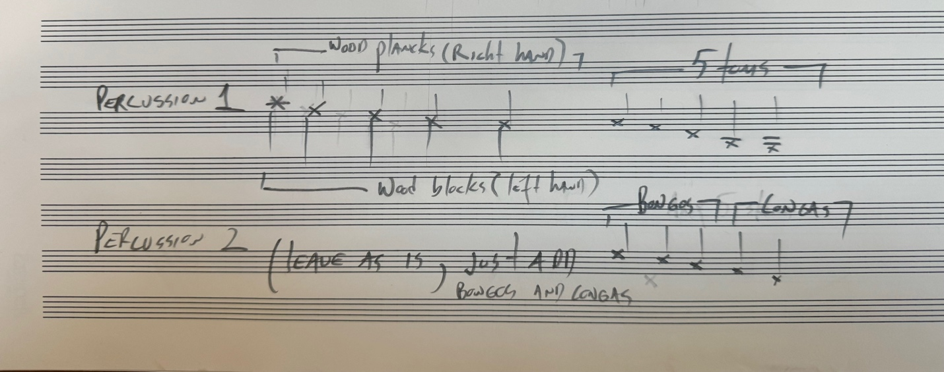

Also note (in the list below) that I changed a lot of Wood passages to now Skin Passages; Please adjust each section to its respective/relative collection of 5 instruments from low to high.

Further Changes in both Percussion Parts

- M1, Perc 1 both hands: please change dynamics from mf to p

- M11 – 13, Perc , both hands: delete all material 9 (Perc materials should return on M14)

- M18- 25, Perc 1, both hands: delete all material

- M29, Perc 2: play Perc 1 (wood plank) part, but on Skins
(include cresc from mf to ff); then make M30-31 also Skins (back to Temple Blocks on M32)

- M26-31, Perc 1: Remove material from right hand (wood plank); Make Perc 1 left hand part into Skins from M26-31; dynamics should be mf with accent on M26, then crescendo from pp in M27 to ff in M30 (back to wood planks and wood blocks on M32)

- M32, Perc 1 and 2: change dynamics to “pp”

- M48 – 54, Perc 2: make entire part Skins

- M49 – 54, Perc 1: make entire part only one staff of Skins (entrance one bar later than Perc 2)

- M55, Perc 1: make dynamics for last note “p”

- M56, Perc 2: make dynamic “mp”

- M57: Make Perc 1 “mf” and Perc 2 “f”

- M58, Perc 1: make “ff”

- M60-61, Perc 1 and 2: make entire part only one staff of Skins each, then back to original wood percussion on M62

- M62 – 68, Perc 1 and 2: aside from ff attacks on 62 and 65, delete all single attacks that don’t have grace-notes and only leave bouncy gestures. More specifically:

Perc 1 right hand (delete beats 2 of M62, 63, 64, and all of M670
Perc 1 left hand (delete all of M63, M66, Beat 3 of M67, and all of M68)
Perc 2 (delete beat 2 of M62, beat 3 of 63, all of M64, M66, and beat 2 of M67 and M68)

- M69 – 71, Perc 1 and Perc 2: Make both parts into Skins, delete Perc 1 M70 (both hands), M71 make it just one staff for Perc 1.

- M73 – 77, Perc 1: make part into Skins, keep only one staff

- M76-77, Perc 2: make part into Skins

- M79 – 98, Perc 1 and 2: make both parts into Skins; and aside from ff attacks on beat 1 of M79, M84, and M95 and beat 2 of M84, delete all single attacks that don’t have grace-notes and only leave bouncy gestures. ALSO make ALL bouncy gestures (except ff ones) start at mp.

More specifically:

Perc 1 right hand (delete M79 beat 3, M80, M82, M86, M89 beat 4, M91 beat 3, M92, M95 beat 3, M96, M98)
Perc 1 left hand (delete M80, 81, M84 beat 3, M86 beat 2, M87, M89 beat 4, M91 beat 1, M92, M96, M97 beat 1,)

Perc 2 (delete M79 beat 3, M81, M82, M84 beat 3, M86 beat 1, M87, M91, M95 beat 3, M97, M98)

- M102, Perc 1 and 2: Make both parts Skins (only one staff for Perc 1); Then between beat 4 of M100 (quarter note tied to whole note) through101 add tremolo roll and crescendo from ppp<ff , on note from first attack on M102 (second highest skin instrument). In other words, introduce first attack on M102 starting on beat 4 of M100 through a tremolo roll.
- M103, Perc 1: beat one should now be respective Skin; also delete bottom staff

- M105 – 115, Perc 1: Should be now all Skin. Make all wood attacks into respective Skins, and keep current tom toms where they are. Keep entire part into one staff. More specifically:

Delete M105 right hand beat 1, M106 right hand, M109 right hand, M110 right hand;

Delete M112 – 115, all right hand part (keep one staff and should now be Skins)
- M122, Perc 1 and 2: Make both parts into respective Skins and make Perc 1 just one staff

- M123, Perc 1: BACK TO WOODS AS ORIGINAL, both hands (2 staffs), make dynamics “p”

- M133 -136, Perc 1 both hands: DELETE entire part.

- M137-141, Perc 1: Delete left hand staff altogether; Right hand part should now be Skins, in “f” dynamics and crescendo to “ff” should start on beat 2 of M140. Please add > accent on first note of M137.

- M141, Perc 2: make part into respective Skin

- M142, Perc 1 and 2: Both parts should be back to Woods as original with Perc 1 in 2 staffs) , but now dynamics should be “pp” for Perc 1 and “p” for Perc 2. ALSO add repeat sign and direction “Repeat 4x Play 5x” for M142 only (make sure it goes also in all parts).

- M154 Perc 1 and 2: Leave as original, keep Wood percussion (I changed this figure in all other instances to Skin…keep this one Wood as an exception)

Minor Corrections and Alterations to all other instruments and Score as a whole:

- M4 – 9, All Strings: please delete all up bows;

- M12, All winds, vl1, vl2, vcl: write “non-legato” before phrase starts←

- M13, Clarinet: second attack should be F ¼ flat, not Fb

- M14-16, viola: delete dynamic change for entire passage, leave viola “mp” until M16 beat 4, where should now be”(mp)” followed by diminuendo. ALSO, add gliss arrow from bottom note of M15 to Bb on M16

- M17, violin 1: start cresc on M18 on Beat 2 of M17 (after one beat of rest)←

- M15 – 28, Strings: delete all up bows;

- M19, Oboe: Change dynamics to “mf (shape dynamics freely)” ; also change “solo” to “solo, espressivo”

- M22, oboe: add F# grace-note (and slur) below first note (Ab sixth tone flat)

- M22-23, oboe: add “bisb” to last note of M22 (D) into beat 1 on M23…show bisbigliando notation with something like a trill wavy like…

- M31, TUTTI: add 2” fermata above barline between M31-32

- M32, add large comma or caesura before downbeat, clear in the score for conductor and in parts for all.

- M28, oboe: add A# below (C#) grace note (and slur) to first note of beat 2 on M28.

- M37 – 51, Strings, delete all up bows;

- M52 and 54, Winds and Strings: make “sfz>p” into “sfzp”

- M55 – 58, All Strings: start each instrument with “sub pp” (instead of “f”) and crescendo to “f” on first note of M58.

- M60, Winds and Strings: make “sfz>p” into “sfzp”

- M61, Strings and Harp: make downbeat “ff”, AND Beat 2 “f” (leave beat 3 as “ff”

- M61, add large comma or caesura before downbeat of 62, clear in the score for conductor and in parts for all.

- M62, M65, M68, M70 (except for last C#), piano: make note heads “x” and write “gestopft”

- M62 – 70: Strings, delete all up bows;

- M64-70, piano: ALL attacks should now be “f” not mp (including ricochet attacks starting now on “f”)

- M71, Winds and Strings: make “sfz>p” into “sfzp”

- M71, Horn, delete strange natural sign after notehead, should be just Bb 1/6 flat

- M75-76, Horn: add slur

- M76, Winds and Strings: make “sfz>p” into “sfzp”

- M77, Harp: Beat 4, Add Low “fff” D 3/4 flat with HALF PEDAL sign and (l.v.) slur in rhythmic unison with Piano….also add dampen Sign (*) together with piano’s on M79.

- M79, Oboe: Change dynamics to “mf (shape dynamics freely)” ; also change “solo” to “solo, espressivo”
- M82, Vl2: missing half note rest

- M86, flute and clarinet: replace rest in Beat 4 with D, which should now start from niente on beat 4 M86 and crescendo through 87 on both parts.
- M79 – 100: strings: add number of gracenotes to anything larger than 3 attacks, such as “(5 attacks)” , “(8 attacks)” , “(13 attacks)”

- M95, flute and clarinet: make both parts into whole note, diminuendo all the way to niente on M96
- M100, oboe: tie oboe note across bar into 101, and diminuendo throughout 100-101 to “ppp”

- M102, Winds and Strings: make “sfz>p” into “sfzp”

- M116, Tutti; add large comma or caesura before downbeat of 117, clear in the score for conductor and in parts for all.

- M118 – 121, piano: make all attacks “ff” and show in both hands.

- M117, Winds: mark espressivo in all wind parts

- M121, fl, ob, cl: Beat 1, remove dot and add 32nd note before high note (to serve as a breath)

- M122, Winds and Strings: make “sfz>p” into “sfzp”

- M127, Sax: Beat 2 has wrong notes, should just continue descending by ¼ tone…should be Eb, E3/4 flat, D

- M129, Winds and Strings (except viola): Beat 1, make crescendo from “P” on first note to “mp”; then make BEAT 2 “sub f” instead of just “f”. ALSO make Winds Beat 3 into ONE SINGLE eight note attack (not two 16ths)

- M131, Fl and Cl: Beat 4, flip flute note with clarinet note

- M141, Tutti; add 2” fermata before downbeat of 142, clear in the score for conductor and in parts for all.

- M142, ALL: as previously described in Percussion edits, add repeat sign and direction “Repeat 4x Play 5x” for M142 only (make sure it goes also in all parts).

- M143, Oboe, Change dynamics to “mf (shape dynamics freely)” ; also change “solo” to “solo, espressivo”

- M148, Sax, delete “legato posibile” and instead slur until Beat 2 of m151. Then slur M151-153.

- M152, clarinet: slur Beat 4 of 152-153

- M153, oboe: beat 1, add A# grace note and slur (above) first attack G1/4 flat

- M154, Oboe and Flute: delete tie from oboe bar before and swap notes between ob and flute…

- M154, Winds and strings: make “sfz>p” into “sfzp”, including oboe (previously “p”)

MAJOR Corrections and Alterations to entire score (will affect bar numbers moving forward):

- M77, TUTTI: make this one bar into FOUR bars, and proportionally stretch exact rhythm in M77 four times slower (instead of dotted 16th; now dotted quarter note and so on until end of FOUR bars). Keep pitches and adjust to following rhythm:

- M116, make this one bar into TWO bars, and proportionally stretch exact rhythm in M116 TWO times slower (instead of dotted 16th; now dotted eight note and so on until end of TWO bars). Keep pitches and adjust to following rhythm:

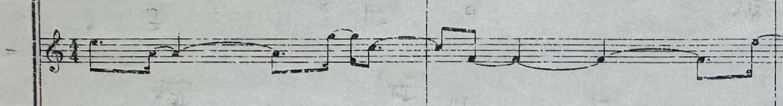

- M136, TUTTI: make this one bar into FOUR bars, and proportionally stretch exact rhythm in M136 four times slower (instead of dotted 16th; now dotted quarter note and so on until end of FOUR bars). Keep pitches and adjust to following rhythm:

